Project Report On
Cloud Kitchen System

Submitted By
Vinit Soni
(Seat No. )

Submitted for
Project Work
BCA Semester - VI (2024-25)

Submitted To

S.G.M. English Medium College of Commerce and Management (SEMCOM)
CVM University

THE CHARUTAR VIDYAMANDAL UNIVERSITY

S.G.M. ENGLISH MEDIUM COLLEGE OF COMMERCE AND MANAGEMENT


VALLABH VIDYANAGAR

CERTIFICATE

DATE: 03/04/2025

This is to certify that Vinit Soni of BCA – SEM - VI (Seat No. <Uni. Exam No.>) has worked on project entitled Cloud Kitchen System from 09/12/2024 to 03/04/2025. This (201150606) is an in-house project course of nine credits.

He was regular in his work and developed the project including analysis and design. He has completed the project satisfactorily

PRINCIPAL PROJECT GUIDE
ACKNOWLEDGEMENT

I would like to express my sincere gratitude to CVM University and SEMCOM for providing the essential resources, infrastructure, and conducive environment that enabled me to undertake my project on the Cloud Kitchen System.

I extend my heartfelt thanks to the Principal of SEMCOM, Dr. Preethi Luhana, for her pivotal role in creating an environment that facilitated my ability to complete this project effectively and efficiently.

I am particularly grateful to my Project Coordinator Mrs. Palak Patel, for offering us the invaluable opportunity to design a system that holds significant potential for future applications.

I would also like to acknowledge the invaluable guidance, support, and insightful suggestions from my project guide, Mr. Premal Soni. His expertise and encouragement were instrumental in overcoming challenges and significantly contributed to the success of this project.

Additionally, I would like to express my gratitude to the lab staff for their support and assistance throughout this project. Their expertise and willingness to help have been invaluable to my learning experience.

Lastly, I extend my deepest thanks to my classmates and friends for their unwavering support, understanding, and patience throughout this journey. Their encouragement has been a constant source of motivation and inspiration.

Sincerely,
Vinit Soni
INDEX

Sr.  No. | Description of Topic | Page  No.
1 | Title Page of Project | -
2 | College Certificate | -
3 | Acknowledgement | -
4 | Index | -
5 | Project Profile | 1
6 | An Existing System | 2
7 | Feasibility Study (OPTIONAL) | -
8 | Hardware and Software | 3
9 | Data Flow Diagram | 4
10 | Database Layout | 5
11 | Screens | 14
12 | Limitations | 43
13 | Conclusion | 44
14 | Bibliography | 45

PROJECT PROFILE
- Introduction:

The Cloud Kitchen System is a web application developed using ASP.NET with Visual Basic. It is designed to help cloud kitchens efficiently manage menu items, customer orders, and kitchen operations. This system streamlines cloud kitchen workflows by automating tasks such as updating menus, managing orders, and securely storing customer information.
The application allows kitchen staff to easily organize and track orders, monitor order statuses, and ensure timely preparation and delivery. With its user-friendly web interface, it provides seamless navigation and enhances the overall experience for both administrators and customers.

- Functionality:

1. Menu Management
- Organized management of food categories and cuisines.
- Easy updates for item availability and details.
2. Order Management
- Seamless handling of customer orders.
- Efficient tracking of order status from placement to fulfillment with email notification.
3. Cuisine & Category Management
- Structured organization for different cuisines and menu types.
4. Customer Information Management
- Secure storage and access to customer details.
- Maintenance of order history for better customer engagement.
5. Payment Integration
- Secure and reliable payment options.
- Generation of order invoices and download it in pdf formate.

6. Reports and Analytics
- Tracking sales trends and generating reports.
- Detailed insights into business performance.
7.User-Friendly Admin Dashboard
- Intuitive interface for system operations.
- Simplified access to essential features and settings.

- Modules:

- Admin Modules
- Authentication: Controls admin access, allowing them to log in and out of the system.
- Menu Management: Enables admins to add, edit, delete, and view Menu.
- Order Management: Allows admins to view, accept/reject, and notify customers about their order status.
- Area Management: Service Area Management interface for controlling delivery zones
- Reporting: Generates reports on food items, customers, orders.

- Customer Modules
- Authentication : Enables customers to register, securely log in, and log out of the system.
- Menu Browsing : Customers can explore available food items by categories and cuisines.
- Order Placement : Enables customers to place orders, track their order status, and manage cart details.
- Contact Support : Provides a communication form for customers to contact administrators or customer service.

EXISTING SYSTEM
- Physical Setup
  - A fully operational kitchen within a designated restaurant space
  - Dining area for customers with tables, chairs, and interior decor
- Order Process
  - Orders are taken by waitstaff in person or through phone calls for takeaway
  - POS systems handle billing and generate receipts
- Menu Availability
  - Fixed or seasonal menu presented through physical menu cards
  - Limited customizations for orders
- Inventory Management
  - Manual or software-based tracking of stock levels for ingredients and supplies
- Staffing
  - Dedicated chefs, kitchen staff, and service staff
  - Roles for cashiering, cleaning, and order handling
- Customer Interaction
  - Direct communication between diners and staff for feedback and service
  - Personalized dining experience with in-person hospitality
- Payment Systems
  - Cash, card, and sometimes mobile wallet payments accepted at the counter
- Marketing & Promotion
  - Flyers, newspaper ads, and local event sponsorships
- Loyalty programs for repeat diners and partnerships with nearby businesses

- Delivery & Takeaway
  - Primarily handled in-house or through call-in orders
  - Limited partnerships with third-party delivery services

FEASIBILITY STUDY

1. Technical Feasibility:
The Cloud Kitchen project is technically feasible due to the availability of advanced web technologies and tools. The project leverages technologies like:
- ASP.NET with VB for robust backend development and data processing.
- SQL Server for secure and efficient data management.
- Dynamic HTML for a modern and responsive user interface.
- The system architecture supports scalability and smooth integration with new features.

2. Operational Feasibility:
The Cloud Kitchen system aims to streamline online food ordering and management processes. The operational feasibility is evident as it:
- Reduces manual effort in order processing and management.
- Improves customer experience with a seamless and efficient ordering process.
- Enables the admin to track orders, manage menus, and analyze sales data effectively.

3. Economic Feasibility:
The project is economically feasible as it requires minimal infrastructure compared to traditional restaurants. Benefits include:
- Lower overhead costs as no dining space is required.
- High profitability due to optimized kitchen operations and reduced staffing needs.
- Increased revenue through online orders and delivery.

4. Social Feasibility:
The project positively impacts society by:
- Providing employment opportunities for delivery personnel and kitchen staff.
- Catering to the growing demand for online food delivery, especially during emergencies or lockdowns.
- Enabling small businesses to expand without investing heavily in dine-in spaces.

HARDWARE AND SOFTWARE

- Hardware:
- Minimal Hardware Requirements:
- Processor: Intel Pentium 4, 1 GHz
- Memory: 8GB SDRAM
- Storage: 256GB Hard disk space
- Input Devices: Keyboard, Mouse

- Minimal Software Requirements:
- Operating System:
  - Windows 10
- Development Environment:
  - Microsoft Visual Web Developer 2010 Express
- .NET Framework:
  - Microsoft .NET Framework v3.5
- Database:
  - Microsoft SQL Server 2005 Express (or SQL Server Compact Edition)
- Office Suite:
  - Microsoft Office 2022 or later versions(For Reports and presentation)
- Web Server:
  - IIS (Internet Information Services)

DATA FLOW DIAGRAM

- Process Hierarchy:
  - Admin :

ADMIN
1.0
Login
2.0
Menu
Management
3.0
Order
Management
4.0
Area
Management
5.0
Report
Generation

  - Customer :

CUSTOMER
2.0
Login
3.0
Menu
4.0
Order
1.0
Registration
5.0
Contact

- Context Level Diagram :

CLOUD
KITCHEN SYSTEM
ADMIN
Food Items
Orders / Reports / Acknowledgement
CUSTOMERS
Registration / Order
Food / Bill /Acknowledgement

Context Level Diagram for Cloud Kitchen System

- Zero Level Diagram :
  - Admin :
Area Details
Acknowledgement

:\Cloud Kitchen\Cloud Kitchen\Admin\AddFoodItems.aspxen\Cloud Kitchen\Admin\AddFoodItems.aspx
:\Cloud Kitchen\Cloud Kitchen\Admin\AddFoodItems.aspxen\Cloud Kitchen\Admin\AddFoodItems.aspx
1.0

Login
MENU_ITEMS
ADMIN
2.0

Menu Management
ADMIN_MST
Admin Credentials
Check Credentials
Acknowledgement
Acknowledgement
Food Details
Save Food Details
Acknowledgement
Acknowledgement
CONTACT_
MESSAGES
MENU_ITEMS
Save Area Details

3.0

Order & Delivery
Management
4.0

Request For Recent Orders
Request For Details

Details / Acknowledgement
Request For Details

Details / Acknowledgement
Zero Level DFD Of Admin For Cloud Kitchen System

5.0

Report Generation
Report / Acknowledgement
Request For Details
Request For Details

Details / Acknowledgement
Request For Recent Orders

Acknowledgement
Area
Management

Orders /Acknowledgement
Order & Delivery
Management

Orders /Acknowledgement

AREA_PINCODE

ORDERS

  - Customer :
Food Details / Acknowledgement
Food Details / Acknowledgement

1.0

Registration
CUSTOMER
2.0

Login
CUSTOMERS
Customer Details
Save Customer Details
Acknowledgement
Acknowledgement
Request for food Details
Customer Credentials
Check Credentials

Acknowledgement
Acknowledgement
Request For Food Details

3.0

Menu
4.0

Order / Cart
5.0

Contact
ORDERS
CONTACT_
MESSAGES

Order / Cart Details
Save Order

Bill / Acknowledgement
Bill /Acknowledgement
Response / Message
Save Details

Acknowledgement
Acknowledgement
Zero Level DFD For Cloud Kitchen System.

MENU_ITEMS

Database Layout

- Customers

Column Name | Datatype | Constraints | Details
C_Id | Integer | Primary Key | Customer Id
C_Name | Nvarchar(30) | Not Null | Customer name
Email | Nvarchar(50) | Not Null | Customer email
Phone | Nvarchar(13) | Not Null | Customer phone
Password | Nvarchar(256) | Not Null | Customer Password

- Menu_category

Column Name | Datatype | Constraints | Details
Category_Id | Integer | Primary Key | Category Id
Category_Name | Nvarchar(30) | Not Null | Category Name
Category_Status | Bit | Not Null | Category Status

- Cuisine_type

Column Name | Datatype | Constraints | Details
Cuisine_Id | Integer | Primary Key | Cuisine Id
Cuisine_Name | Nvarchar(30) | Not Null | Cuisine Name
Cuisine_Status | Bit | Not Null | Cuisine Status

- Menu_Item

Column Name | Datatype | Constraints | Details
M_Id | Integer | Primary Key | Menu Id
M_Name | Nvarchar(50) | Not Null | Menu Item Name
M_Category_Id | Integer | Foreign Key | Category Id (Menu_category)
M_Cuisine_Id | Integer | Foreign Key | Cuisine Id (cuisine_type)
M_Description | Nvarchar(255) | Allow Null | Menu Item Description
M_Price | Decimal(6,2) | Not Null | Menu Item Price
M_Discount | Decimal(5,2) | Not Null | Menu Item Discount
M_Final_Price | Decimal(6,2) | Not Null | Menu Item Final Price
M_Image_Url | Nvarchar(Max) | Not Null | Menu Item Image Path
M_Availability | Bit | Not Null | Menu Item Availability
M_Featured | Bit | Not Null | Is Item Featured or not
M_Status | Bit | Not Null | Menu Status

- Orders

Column Name | Datatype | Constraints | Details
Order_Id | Integer | Primary Key | Order Id
C_Id | Integer | Foreign Key | Customer Id(Customers)
Total_Amount | Decimal(8, 2) | Not Null | Order Total Amount
Order_Status | Nvarchar(50) | Not Null | Order Status
Order_Date | Datetime | Not Null | Order Date
Address | Nvarchar(255) | Not Null | Delivery Address
Pincode | Nvarchar(6) | Not Null | Area Pincode
Payment_Type | Nvarchar(10) | Not Null | Payment Method
Transaction_Number | Nvarchar(50) | Not Null | Transaction Number

- Order_Details

Column Name | Datatype | Constraints | Details
Order_Detail_Id | Integer | Primary Key | Order Item Id
Order_Id | Integer | Foreign Key | Order Id (Orders)
M_Id | Integer | Foreign Key | Menu Id(Menu_Item)
Quantity | Integer | Not Null | Food Quantity
Price | Decimal(6, 2) | Not Null | Food Item Price
Total_Price | Decimal(8, 2) | Not Null | Total Price

- Area_Pincode

Column Name | Datatype | Constraints | Details
Area_Id | Integer | Primary Key | Area Id
Area_Name | Nvarchar(255) | Not Null | Area Name
Pincode | Nvarchar(10) | Not Null | Area Pincode

- Contact_Messages

Column Name | Datatype | Constraints | Details
Message_Id | Integer | Primary Key | Message Id
C_Id | Integer | Foreign Key | Customer Id(Customers)
Message | Nvarchar(MAX) | Not Null | Message
Submitted_At | Datetime | Not Null | Submited Date & Time
Status | Bit | Not Null | Message Status

Screenshots

- Dashboard Page
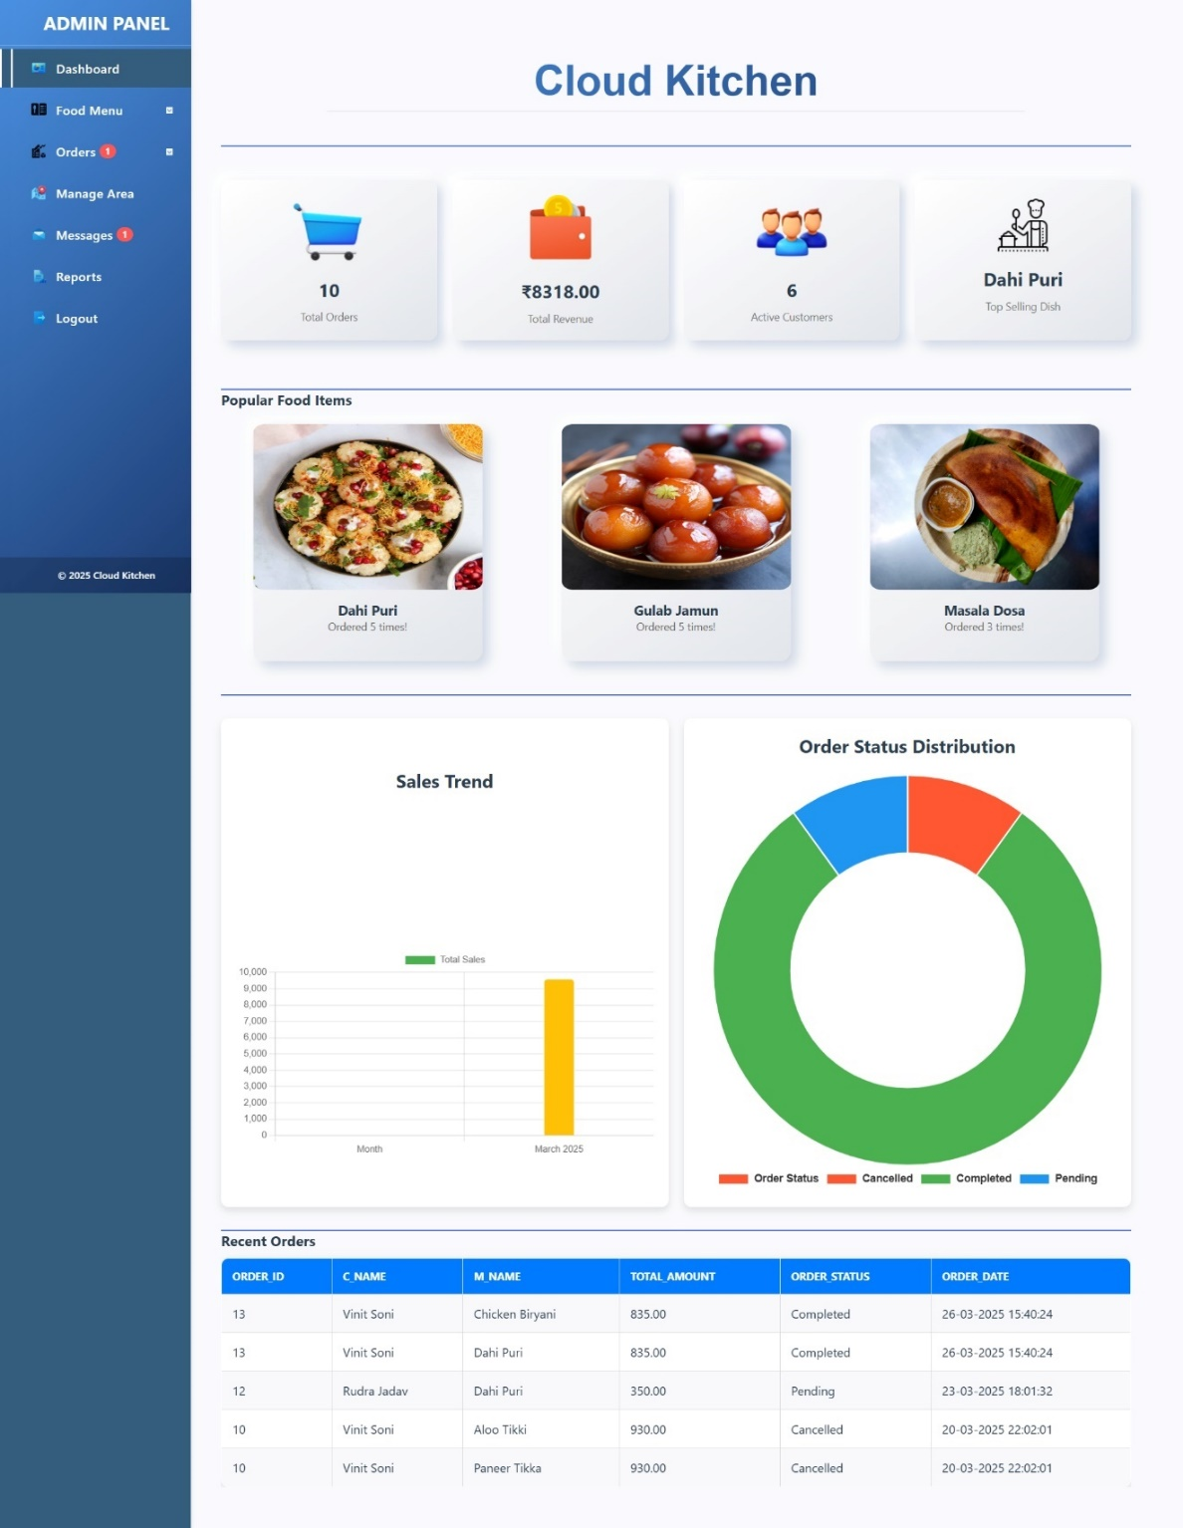

- The Cloud Kitchen admin dashboard provides a quick overview of key metrics, including total orders, revenue, active customers, and the top-selling dish. It features popular food items, a sales trend chart, and an order status distribution chart. The recent orders table displays order details like customer name, menu item, total amount, order status, and date.
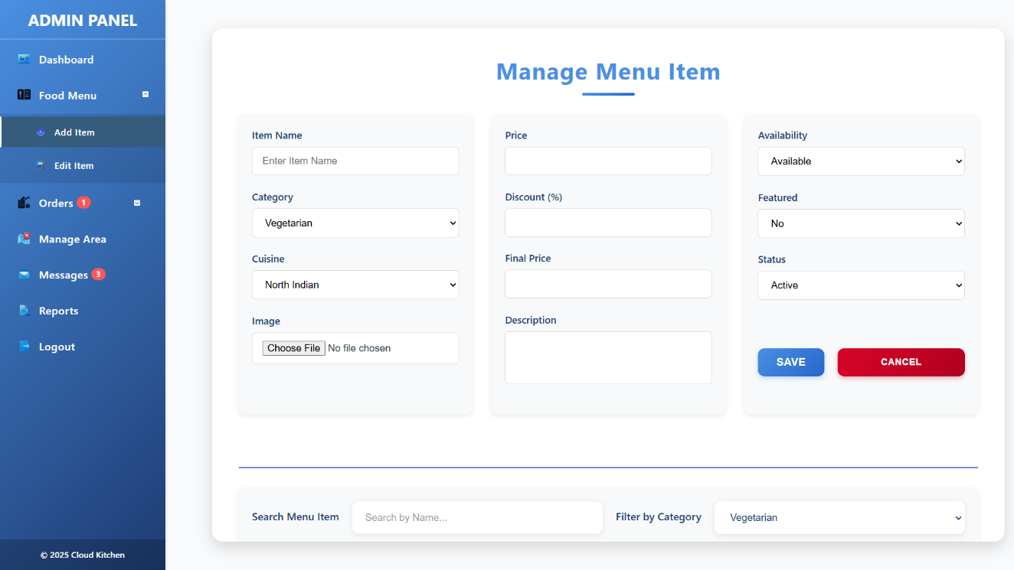
- Manage Menu Item Page

- The "Manage Menu Item" page in the Cloud Kitchen admin panel allows admins to add, edit, and manage food items efficiently. It includes fields for item name, category, cuisine, price, discount, final price, description, availability, featured status, and overall status. Admins can upload an image and easily search or filter menu items. The "Save" and "Cancel" buttons provide quick action options, while the clean and modern layout ensures a smooth user experience.

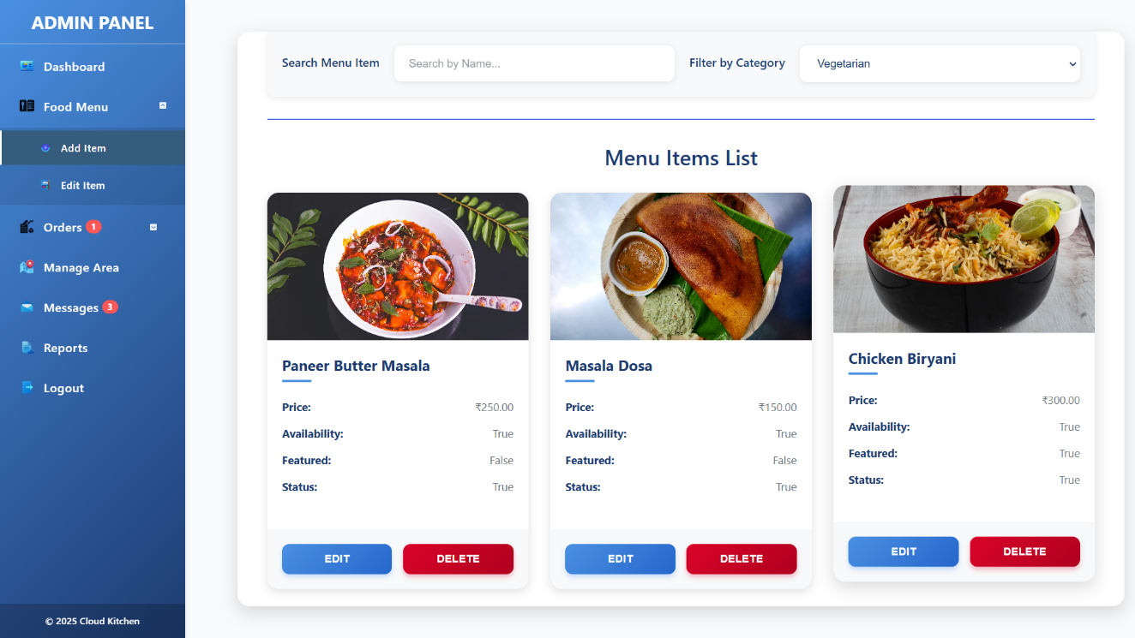
- The "Menu Items List" page in the Cloud Kitchen admin panel displays all available food items with their details, including price, availability, featured status, and overall status. Each item is presented in a visually appealing card format with an image and quick action buttons for editing or deleting the item. The search bar and category filter make it easy to find specific items, while the clean layout enhances usability.

- Manage Category and Cuisine Page

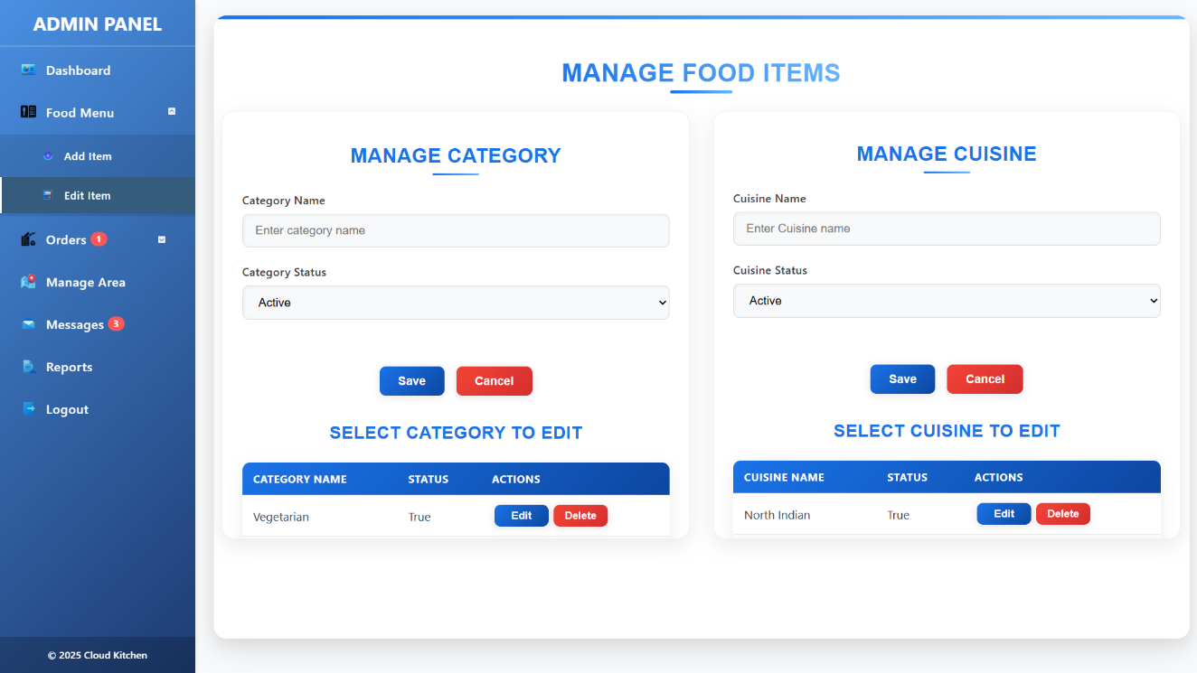
- The "Manage Food Items" page in the Cloud Kitchen admin panel provides an intuitive interface for managing food categories and cuisines. It is divided into two sections: one for managing categories and the other for managing cuisines. Each section includes input fields for entering names, dropdowns to set the status (such as Active), and action buttons for saving or canceling entries. Below these input forms, tables display existing categories and cuisines along with their statuses. Each entry in the table includes options to edit or delete using clearly labeled buttons.

- Manage Orders Page :
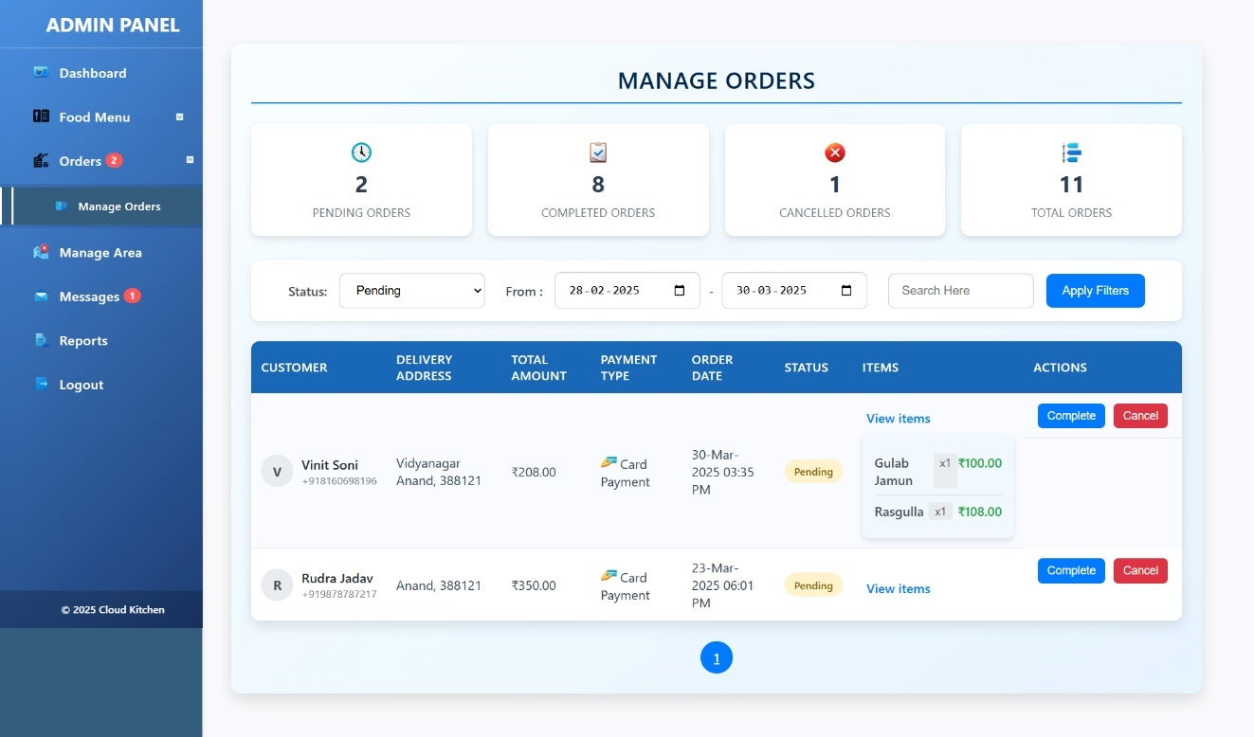

- The Cloud Kitchen admin panel serves as a centralized order management dashboard where staff oversee all customer orders. The interface presents order statistics with counts for pending, completed, and canceled orders, while offering robust filtering, detailed order viewing, and status update capabilities.

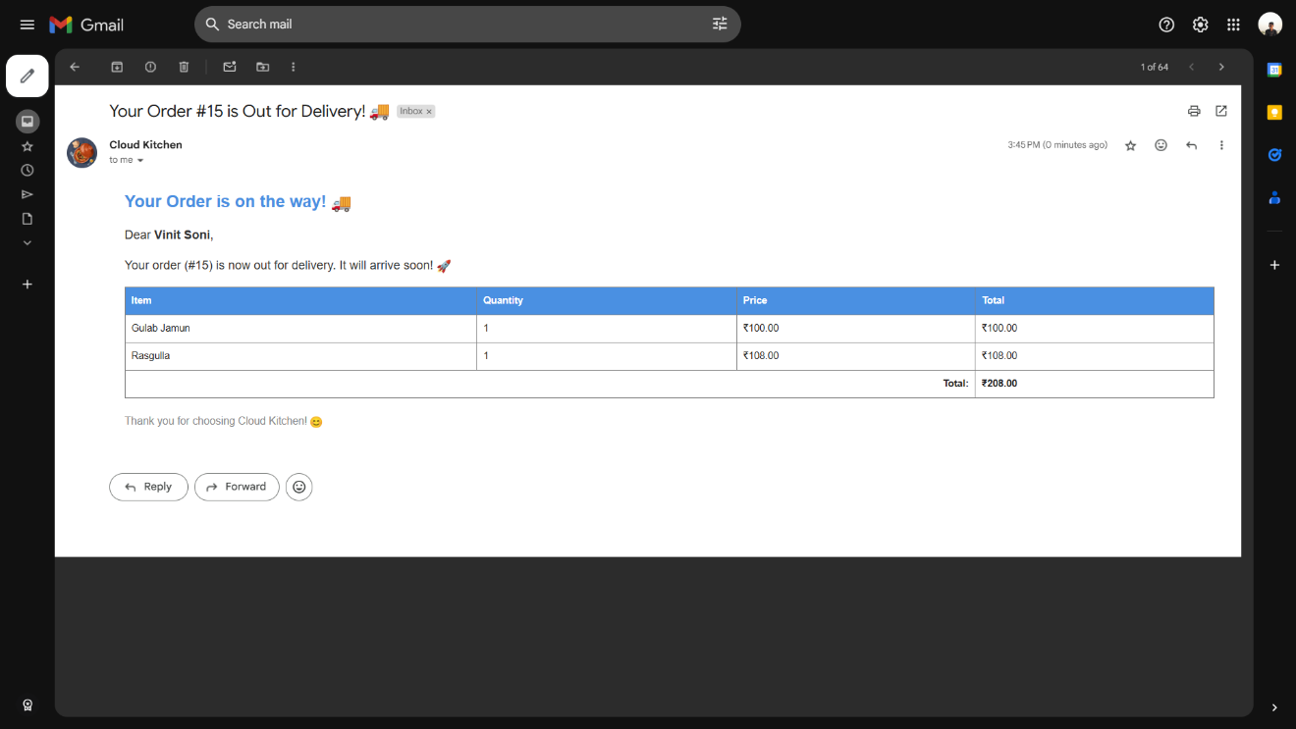

- An automated delivery notification email is triggered when an order status changes to "out for delivery." This communication keeps customers like Vinit Soni informed about their order's progress, listing the purchased items (Gulab Jamun and Rasguila) and total cost (₹208.00).

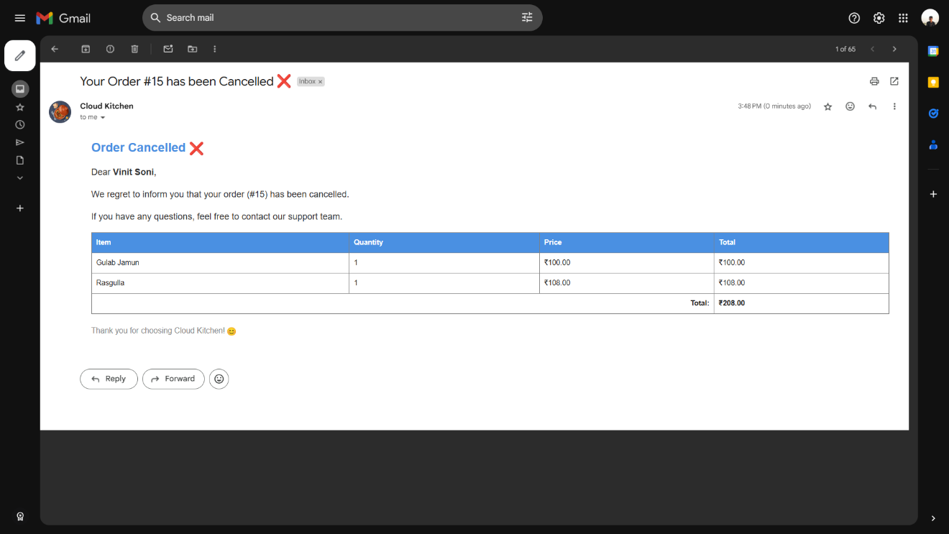

- Similarly, an automated cancellation notification email is generated when an order is canceled in the system. This message informs customers about the change in order status, maintains transparency regarding the canceled items, and provides guidance for further assistance from the support team.

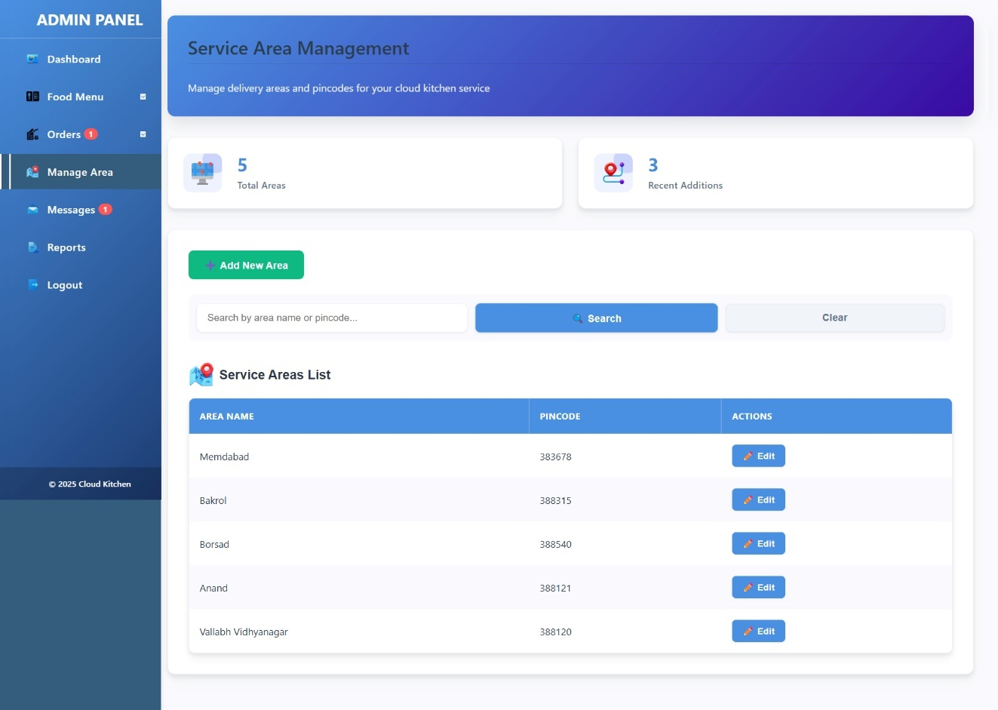
- Manage Area Page

- The Cloud Kitchen admin panel features a comprehensive Service Area Management interface for controlling delivery zones. The main dashboard presents an overview of delivery coverage, displaying 5 total service areas with 3 recent additions. Administrators can efficiently search for specific locations using area names or pincodes, with the current list showing areas like Mehmdabad, Bakrol, Borsad, Anand, and Vallabh Vidyanagar with their corresponding pincodes.
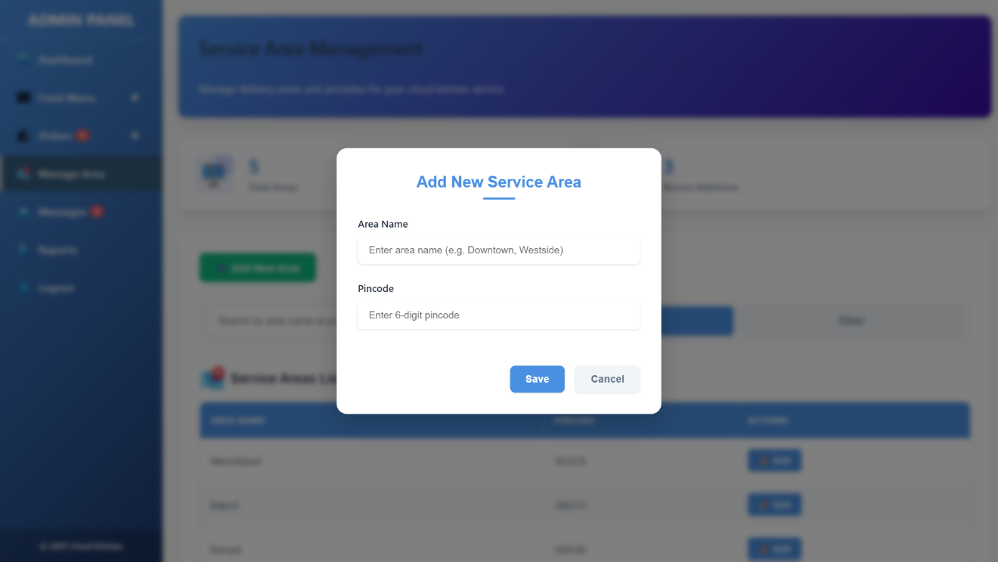

- The system facilitates service area expansion through an intuitive "Add New Service Area" modal that prompts administrators to input area names and 6-digit pincodes. This streamlined process allows for quick additions to the delivery network while maintaining organized records.

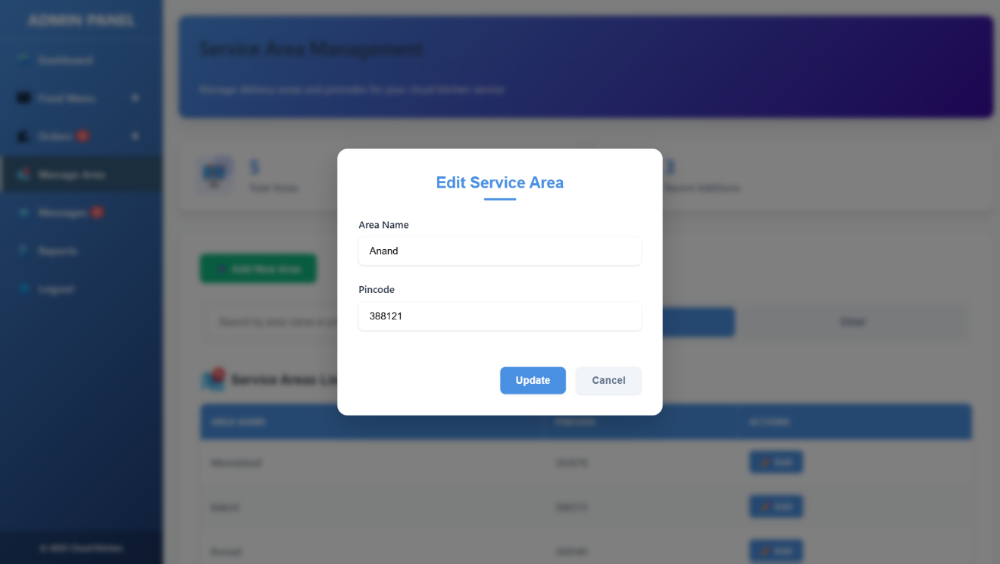

- For maintaining accurate delivery zone information, the platform includes an "Edit Service Area" functionality. This feature enables administrators to modify existing entries, as demonstrated with the Anand area (pincode 388121) being updated. The edit modal preserves the current information while allowing for necessary adjustments, ensuring the delivery network remains current and accurate.

- Manage Responses Page

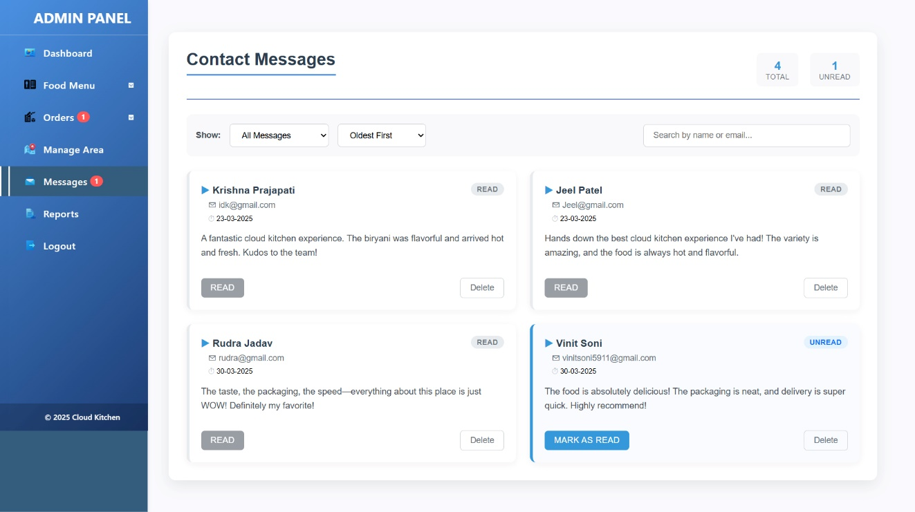

- The customer testimonials highlight the quality of Cloud Kitchen's service, praising the flavorful food, prompt delivery, neat packaging, and overall exceptional cloud kitchen experience. This interface allows administrators to efficiently monitor and respond to customer communications, helping maintain service quality.

- Report And Analysis Page

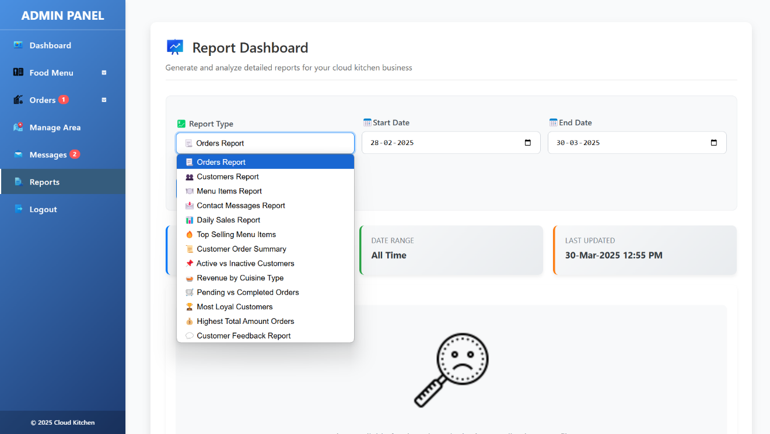

- The Report Dashboard provides an intuitive interface where administrators can easily generate various report types by selecting from a dropdown menu. Options include Orders Report, Customers Report, Menu Items Report, and specialized reports like Top Selling Menu Items or Customer Feedback. The clear date range selectors allow for customized time periods, ensuring relevant data collection.

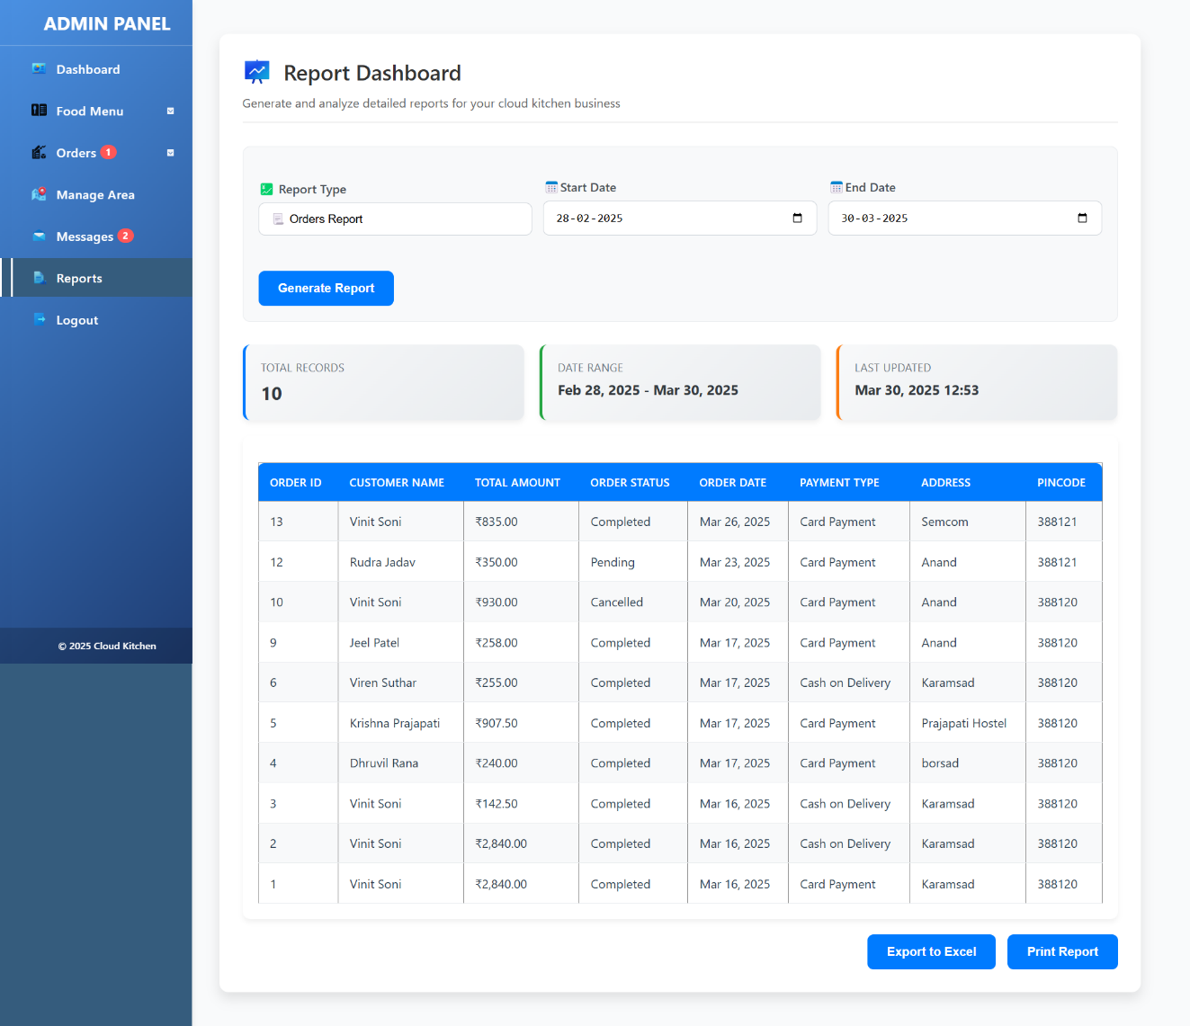

- The Orders Report functionality displays comprehensive order information in a well-organized table format. With 10 records shown for the February 28 to March 30, 2025 period, administrators can quickly scan important details like order status, payment methods, and delivery locations. The interface includes convenient action buttons for exporting to Excel or printing reports.

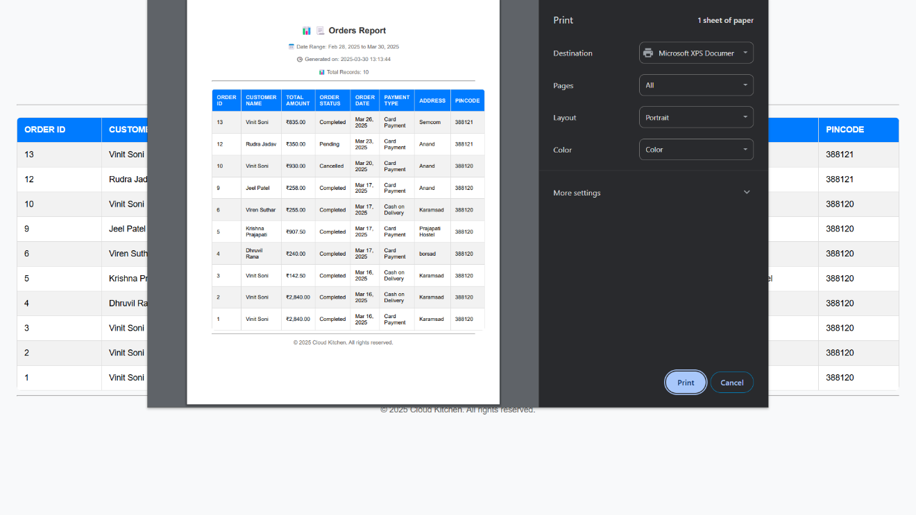
- The print dialog for the Orders Report, allowing administrators to customize printing options like destination ,paper size, layout, and color settings before printing the report and the report will be saved as pdf in local storage .
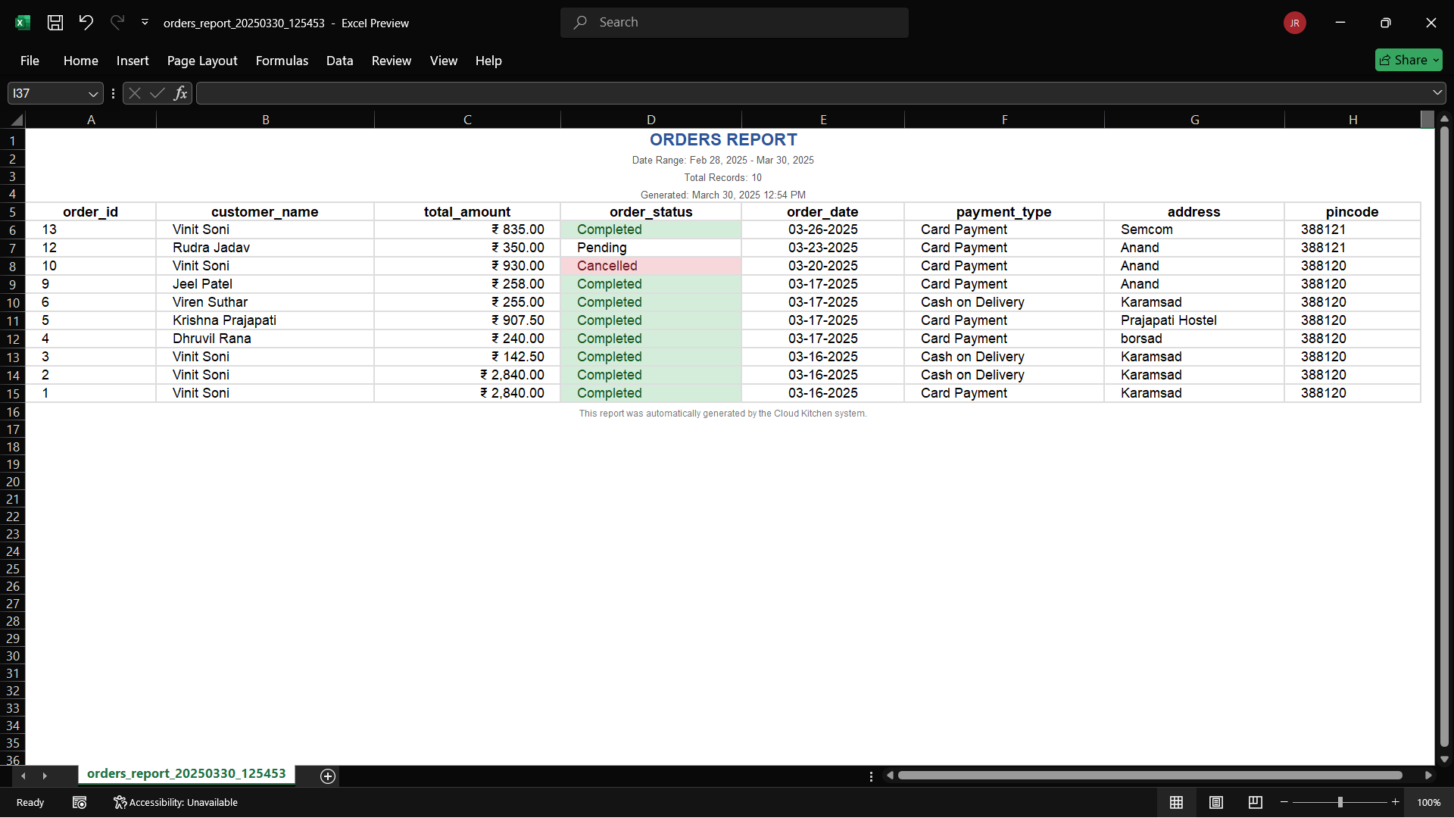

- The system's export capabilities enhance usability by allowing data to be transferred to Excel with automatic formatting that highlights different order statuses through color-coding (completed orders in green, pending in yellow, cancelled in red). This visual distinction helps quickly identify order statuses at a glance.

- Home Page

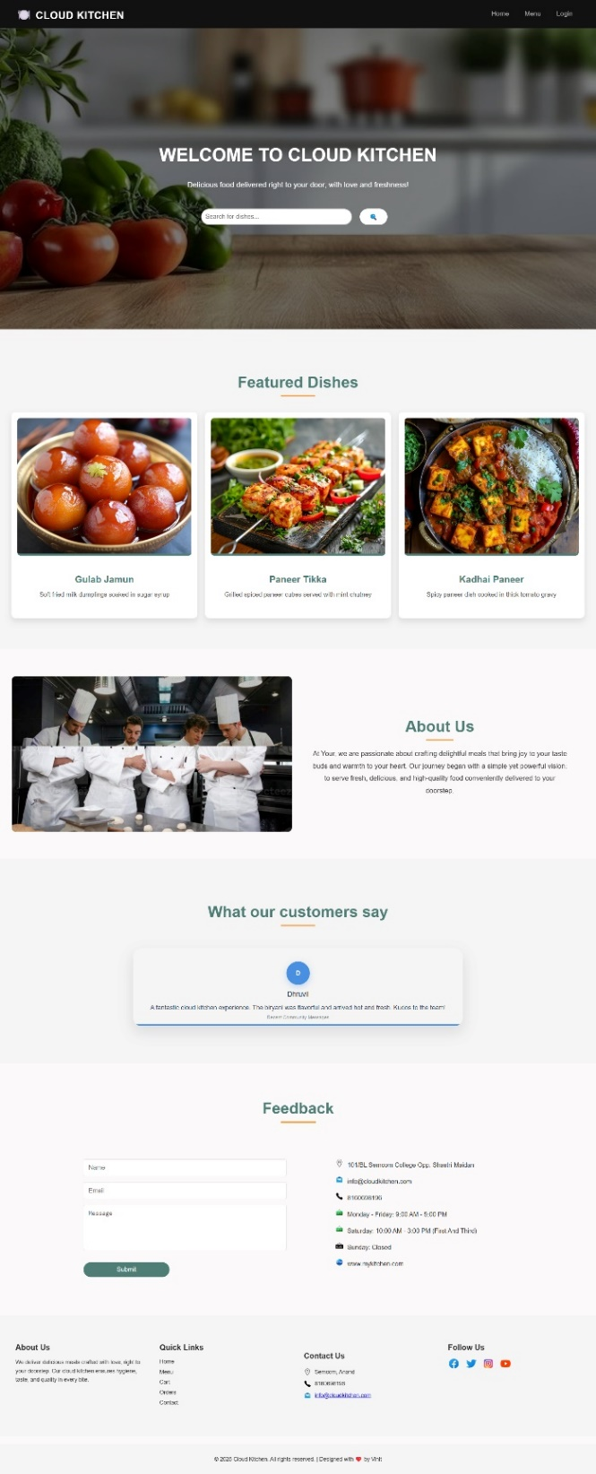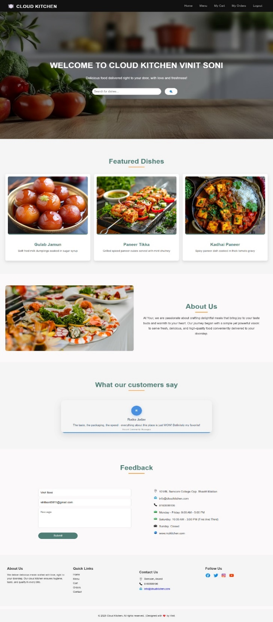
- The first image shows the Cloud Kitchen homepage for guests, featuring a welcome message, search bar, featured dishes, an About Us section, and a contact form. The second image is a personalized version for a logged-in user, displaying their name, additional navigation options (My Cart, My Orders, Logout), and pre-filled contact details.
- Registration Page :

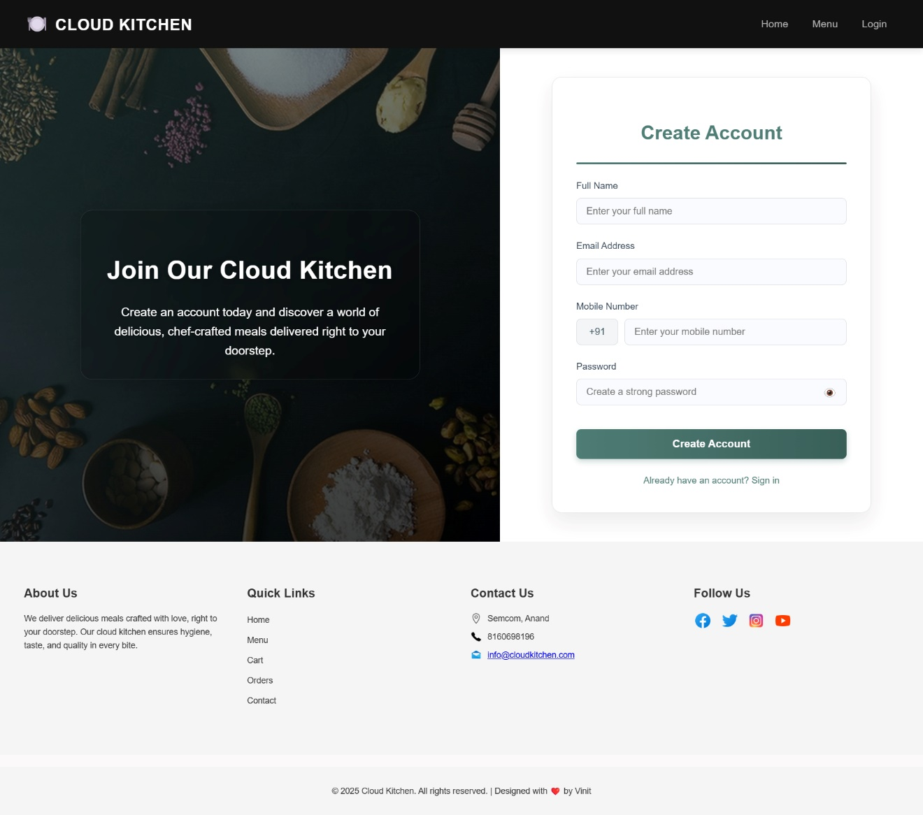

- Registration form with fields for Name, Email, Mobile, and Password.
- "Create Account" button to submit.
- Footer with About Us, Quick Links, Contact, and Social Media.

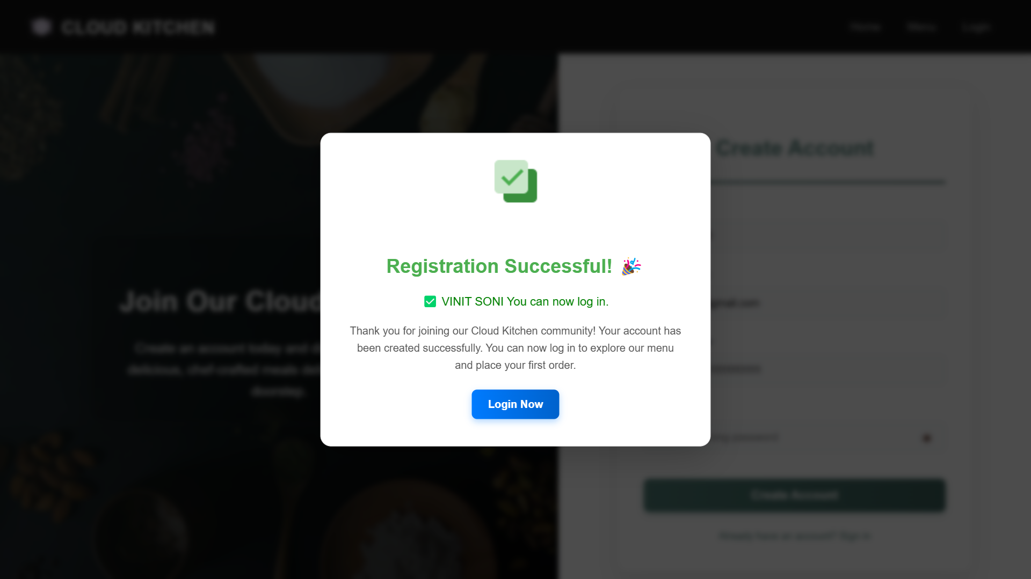

- A pop-up confirmation modal appears after successful registration.
- Displays "Registration Successful!" with a checkmark icon.
- Highlights the registered user's name and confirms they can now log in.
- Provides a "Login Now" button to proceed to the login page.

- Login Page :

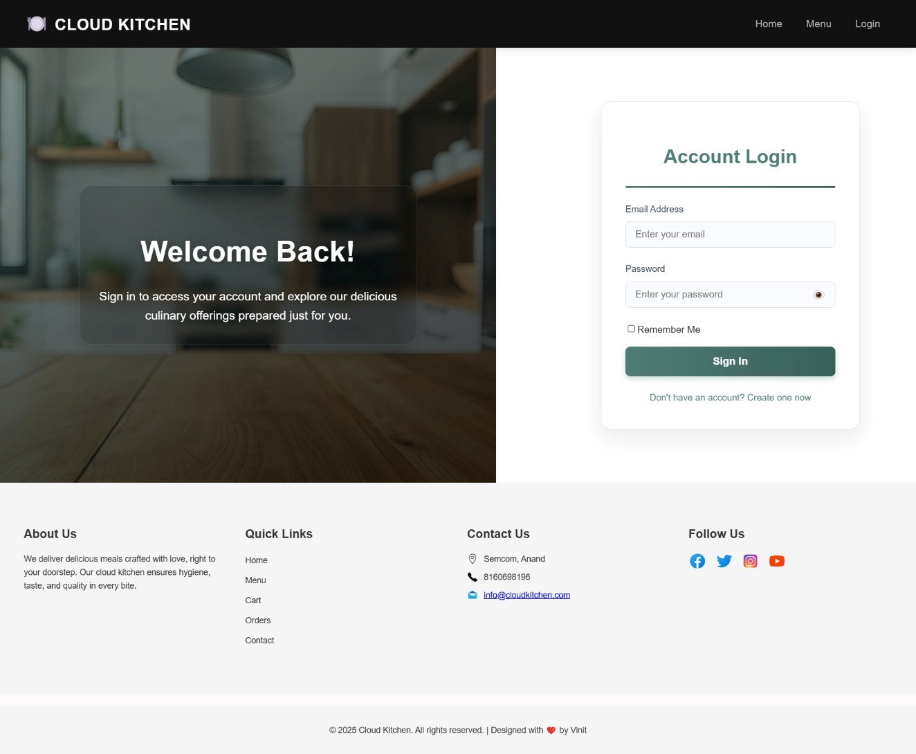

- The Cloud Kitchen login page is simple and user-friendly. A warm welcome message invites users to sign in, while the login form allows quick access with an email and password. A "Remember Me" option ensures convenience, and new users can easily register via "Create one now.".

- Menu Page :

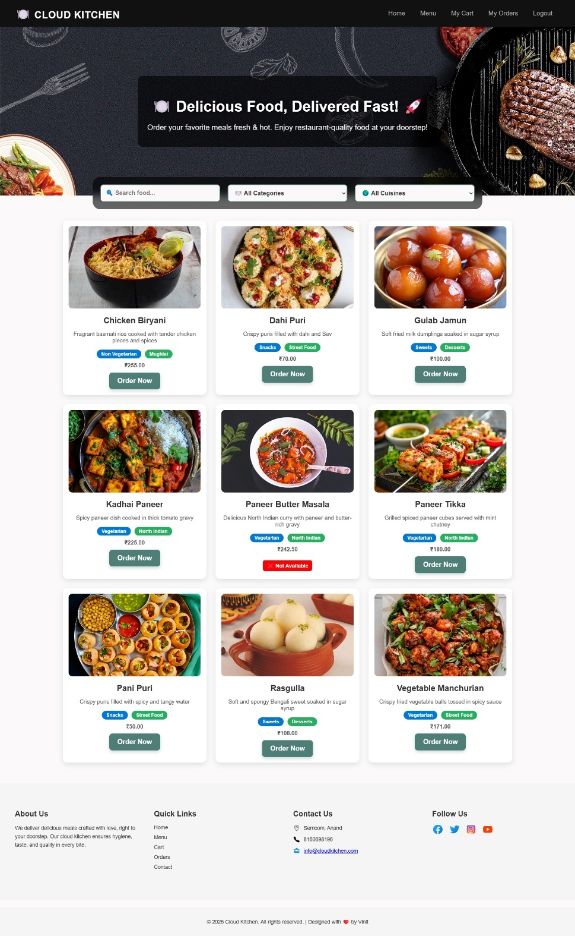

- The Cloud Kitchen menu page offers a seamless food ordering experience with a search bar, category and cuisine filters, and visually appealing dish cards. Each card displays a high-quality image, description, price, and tags, with an "Order Now" button for quick access. Unavailable items are clearly marked.

- Cart Page :

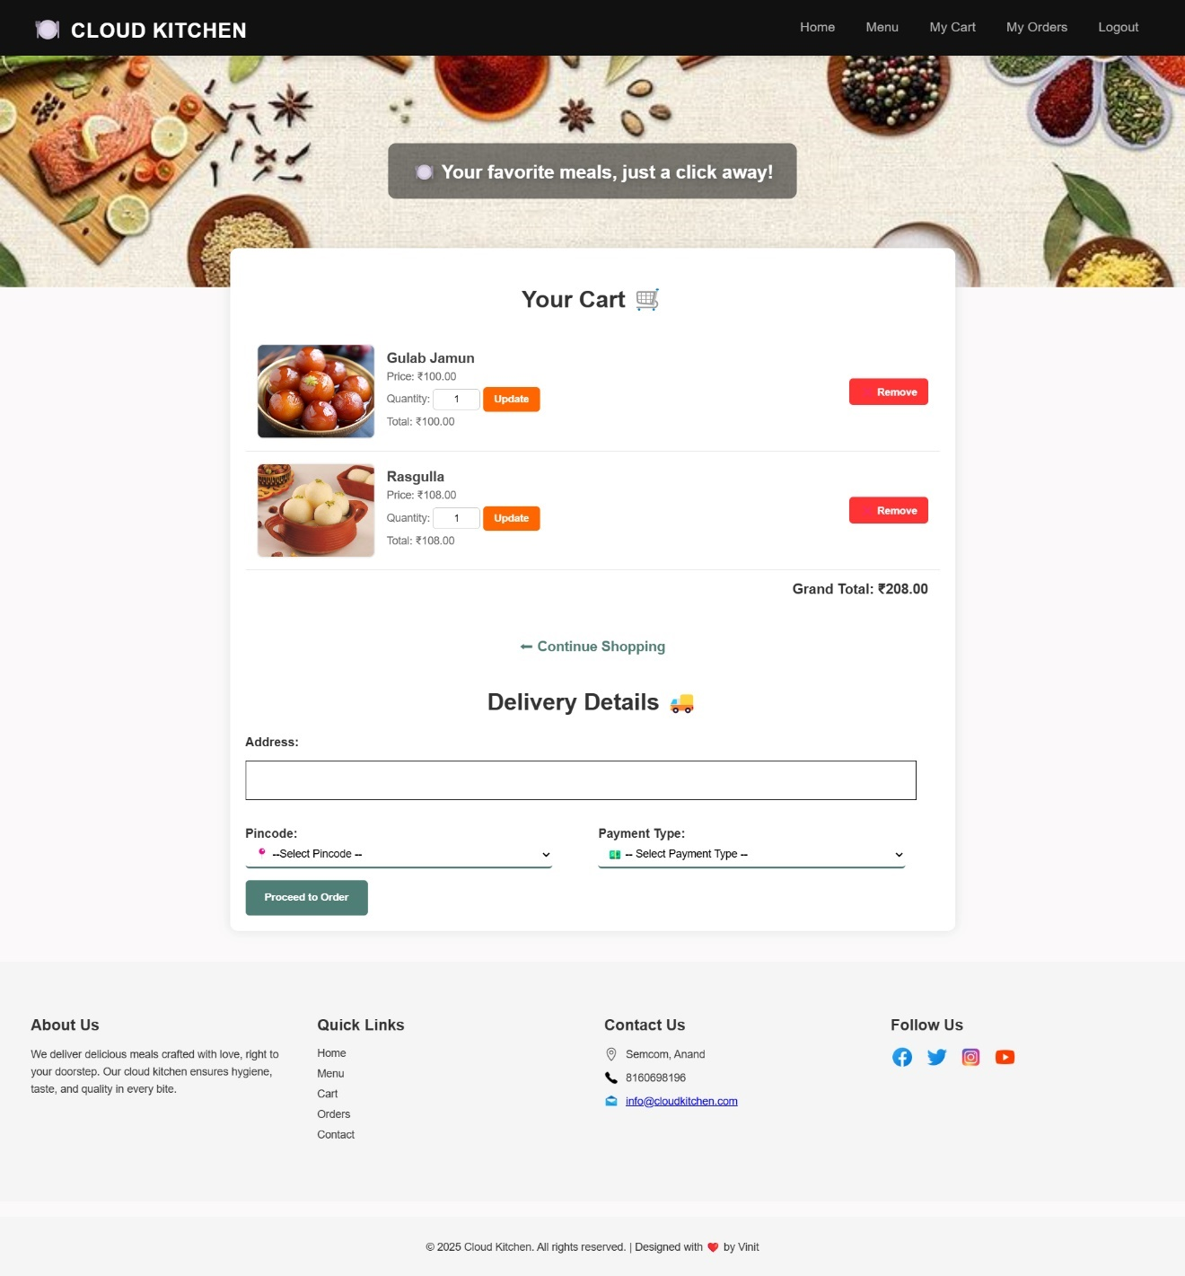

- The Cloud Kitchen order page displays selected items (Gulab Jamun and Rasagulla) with their prices and quantities. Users can easily modify their order with quantity adjustments or removal options before entering delivery details and payment information. The clean layout guides customers through the checkout process with clear visual cues.

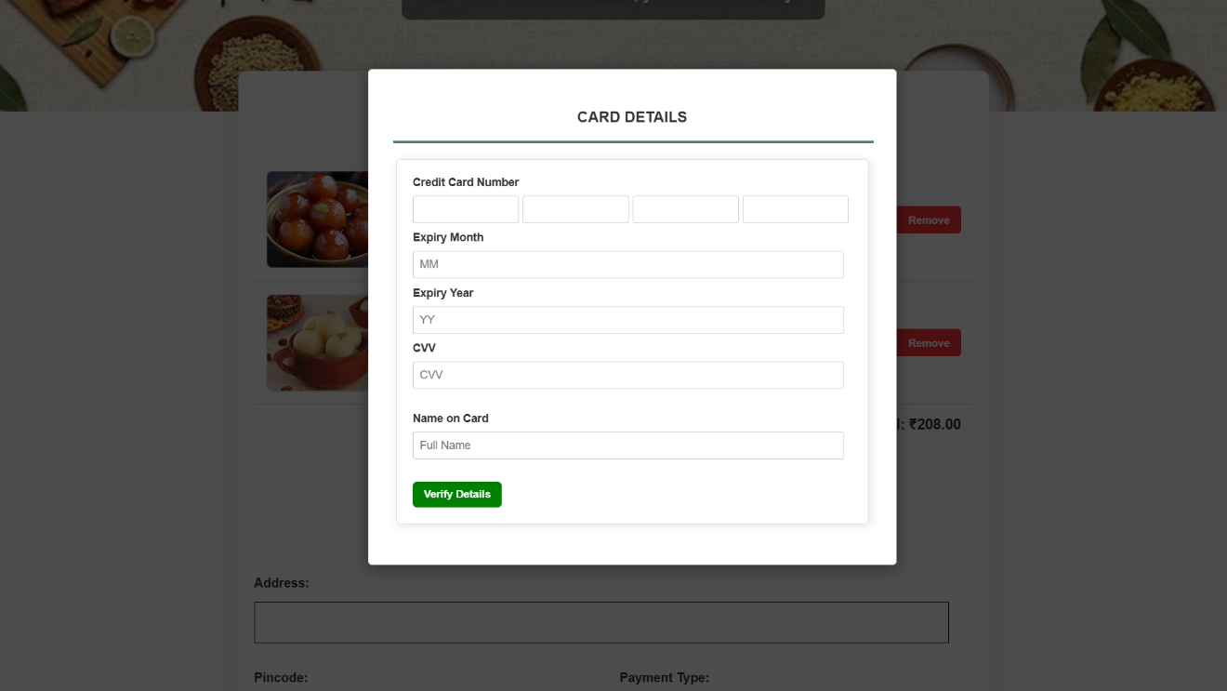

- When selecting card payment, users are presented with a straightforward card details form. The clearly labeled fields request only essential information for secure payment processing, with each input field properly separated for easy data entry.

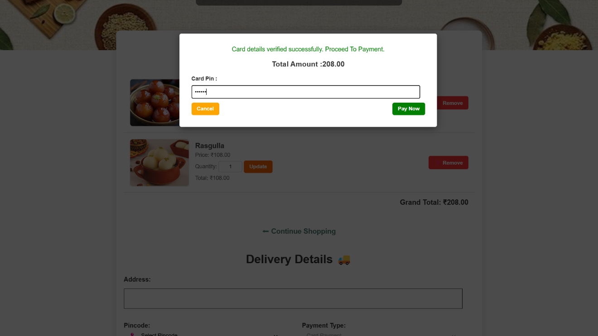

- After entering card details, customers verify their transaction by entering their card PIN. The verification screen clearly displays the total amount (₹208.00) and provides distinct Cancel and Pay Now buttons, giving users final control before completing their purchase.

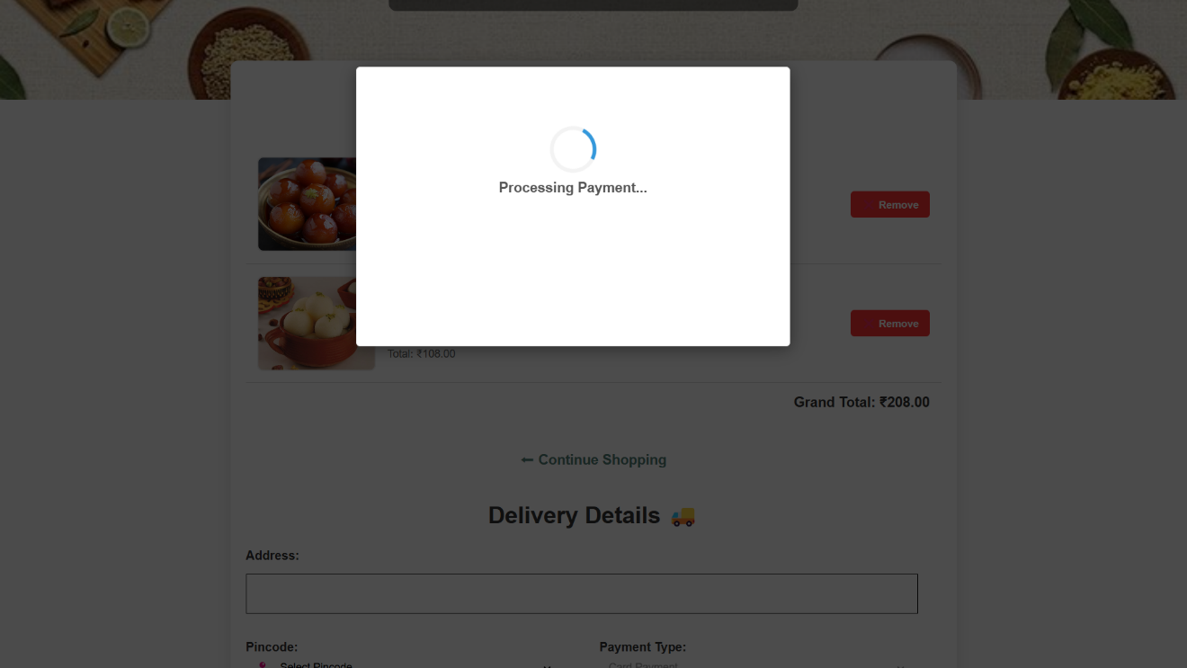

- The processing payment screen features a simple loading animation that reassures customers their transaction is being handled. This transitional screen prevents user anxiety by indicating the system is actively working on their payment request.

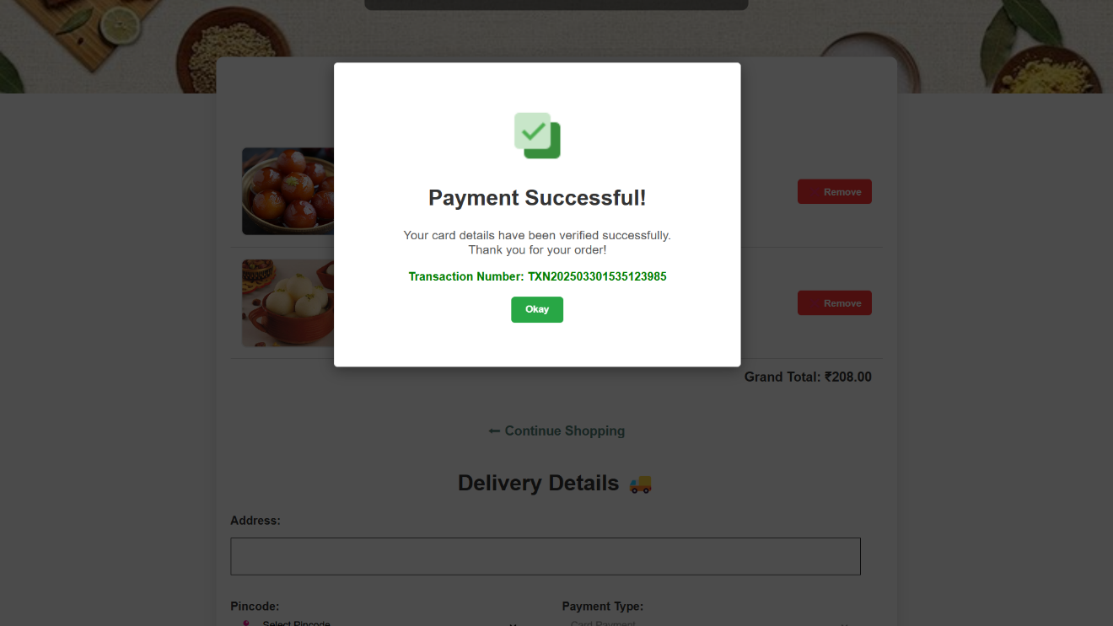

- The payment confirmation screen provides immediate visual feedback with a green checkmark icon. The transaction number is clearly displayed for reference, and the Done button allows users to proceed once they've acknowledged their successful payment.

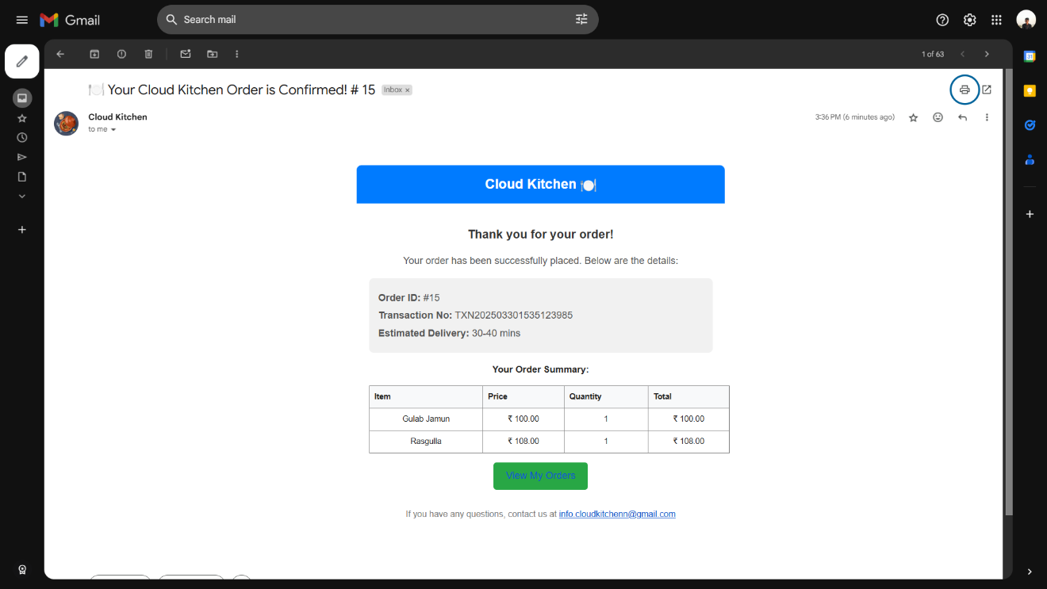

- The order confirmation email provides a comprehensive summary of the purchase. Important details like order ID, transaction number, and estimated delivery time are prominently displayed, giving customers confidence their order has been received and is being processed.

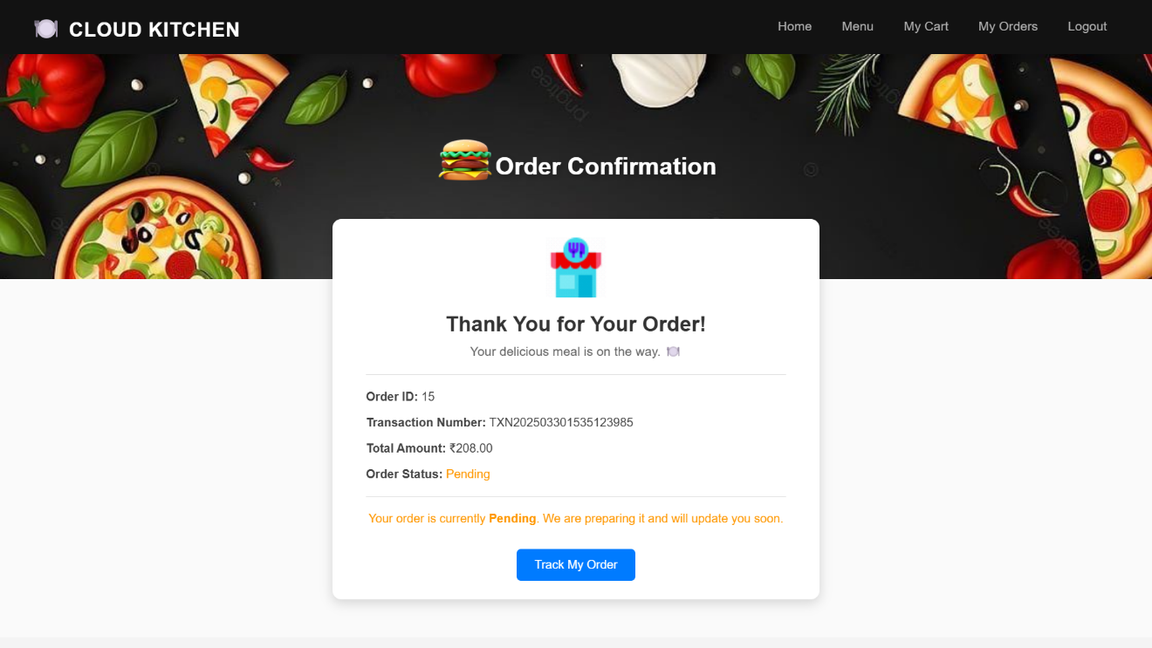

- The order confirmation page provides a clear summary of your purchase with essential details like Order ID, Transaction Number, and Total Amount. The colorful food-themed header creates an appetizing atmosphere, while the prominent "Track My Order" button makes it easy to monitor your delivery. The status notification ("Your order is currently Pending") keeps you informed about your food preparation progress.
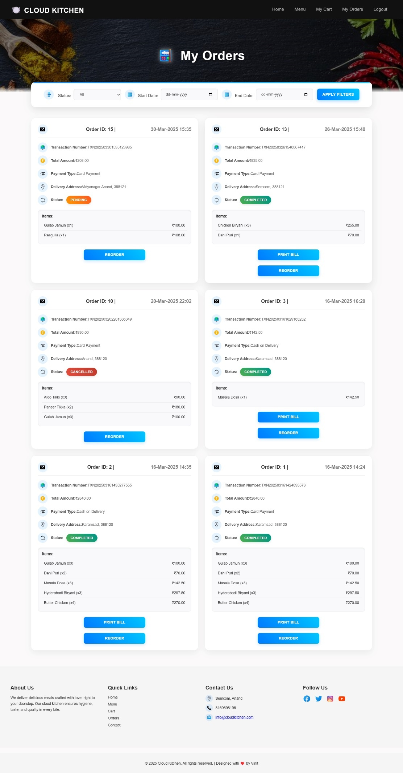

- The My Orders section organizes all your previous orders in an easy-to-scan format with filter options to locate specific purchases. Each order card displays important information including transaction details, delivery address, and itemized list of dishes with quantities and prices. The convenient "Reorder" and "Print Bill" buttons allow for quick repeat purchases or documentation of your orders.

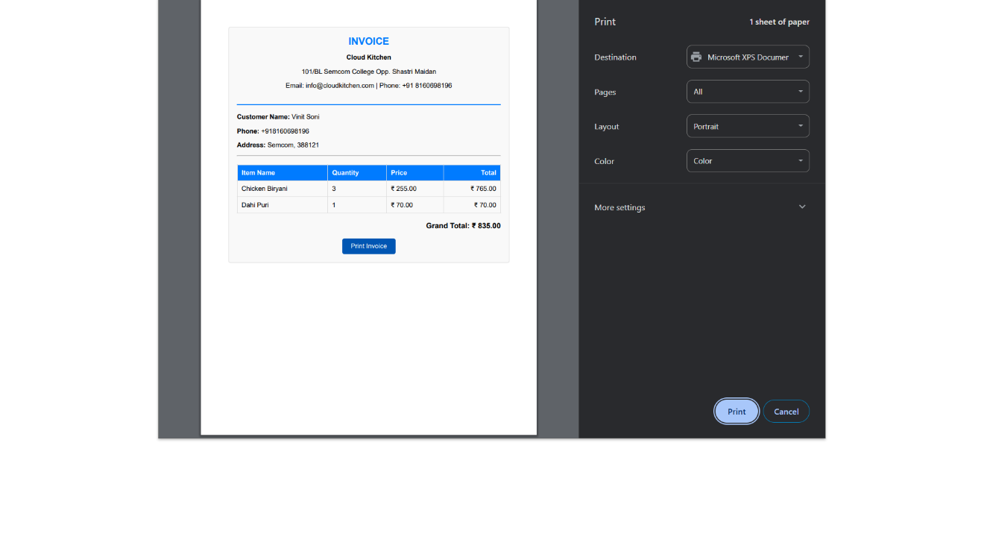

- The invoice print preview shows a professionally formatted receipt with complete vendor and customer information. The clearly structured itemized list breaks down your order with quantity, individual prices, and total amounts for each dish. The print dialog on the right offers simple customization options to save or print your receipt according to your preferences.

LIMITATIONS

- No Payment Integration:
  - The current system does not include online payment processing, which may limit customer convenience compared to competitors offering integrated payment options.
- Stock Management Exclusion:
  - The system lacks automated stock management, making it challenging to track inventory levels directly within the platform.
- Customer Feedback Handling:
  - The system does not actively collect or analyze customer feedback, limiting insights into customer satisfaction and areas for improvement.
- Backend-Only UI Handling:
  - Managing UI changes solely through the backend may result in slower updates and limited interactivity compared to client-side scripting.
- Limited Collaboration Features:
  - The current version does not support multi-user collaboration or role-based access control, making it difficult for multiple staff members to manage orders and inventory simultaneously. This can be considered as a future enhancement.
- No Real-Time Order Tracking:
  - Customers do not have the ability to track their orders in real-time, which could enhance transparency and customer satisfaction.
- Integration with External Services:
  - The system does not integrate with third-party delivery partners or customer relationship management (CRM) tools, which could improve operational efficiency.

CONCLUTION

The Cloud Kitchen project successfully addresses the growing demand for efficient online food ordering and management. By offering a streamlined and user-friendly platform, it simplifies order processing, menu management, and customer interaction, making it a valuable tool for cloud kitchen operators. The system's intuitive interface and modern design enhance user experience, while backend-driven UI updates ensure consistency and reliability.
Despite its numerous strengths, the project also has certain limitations, such as the lack of payment integration, collaboration features, and real-time order tracking. Addressing these limitations in future updates would significantly enhance the system's functionality and user satisfaction. Overall, the project lays a solid foundation for efficient cloud kitchen operations, with ample scope for future enhancements and scalability.

BIBLIOGRAPHY

- Books and Journals:
  - Smith, J. (2021). Digital Transformation in Food Services. Tech Publishers.
  - Brown, A. (2020). Cloud Kitchens: Revolutionizing Food Delivery. Journal of Food Technology, 15(3), 45-60.
- Web Resources:
  - "The Rise of Cloud Kitchens." (2022). FoodTech Magazine. Retrieved from www.foodtechmag.com/cloud-kitchens
  - "How Cloud Kitchens are Changing the Restaurant Industry." (2023). TechCrunch. Retrieved from www.techcrunch.com/cloud-kitchen-trends
- Government and Industry Reports:
  - National Restaurant Association (2023). Impact of Technology on Food Delivery Services.
  - Food and Beverage Industry Analysis Report (2022). Global Market Insights.
- Software and Technologies Used:
  - ASP.NET with VB for backend development.
  - SQL Server for database management.
  - Chart.js for dashboard visualization.
  - HTML, CSS for frontend design.

